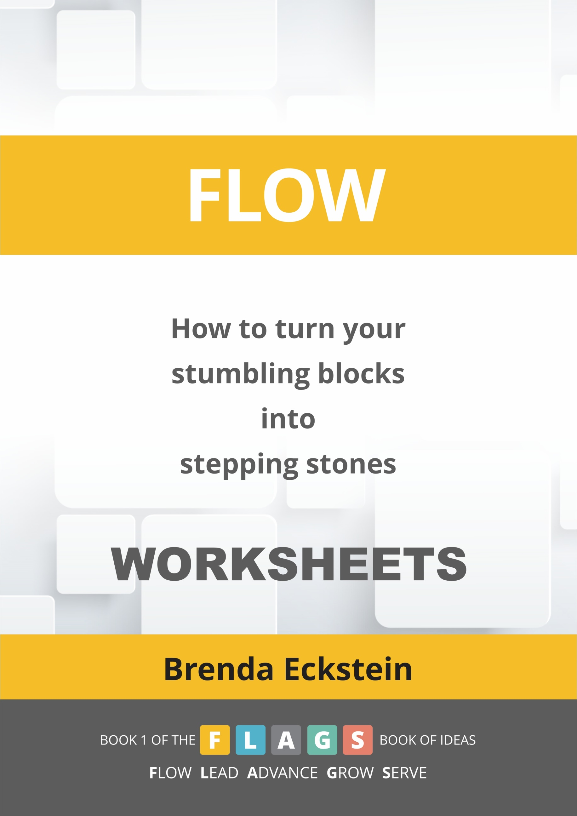

Instructions for using the worksheets

So I trust that in having read each chapter of Flow: How to change your stumbling blocks into stepping stones and having taken the time to reflect, you now have insights which you would like to record. For this reason we have provided a downloadable and printable workbook for journaling your insights.
The chapters correspond to those in the book. Just to remind you: The first box, called ‘Reflection and Generalisation’, is where you can reflect on the insights or learning points observed from the chapter and how they apply to your life as generalisations. The second box, called ‘Active Experimentation’, is where you can write down what action you intend taking. Have fun deciding how you can experiment by doing something differently as a result of the experience of reading the chapter.
Obviously, your main aim in reading the book and completing the worksheets, is to use your talents, notice your energy levels, improve your skills and challenge yourself to a point where you are in a state of flow. If you are an educator, trainer or coach, you’ll also be reflecting on how you can help others to find ways of reaching that state.
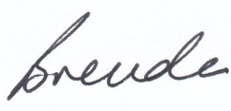
Brenda Eckstein International
www.strategy-leadership.com/

Regeneration

Reflection and generalisation
Three of my learning points through reading this chapter:

Active experimentation
As a result of the above I am going to take the following action:

New Year resolutions: the morning after…

Reflection and generalisation
Three of my learning points through reading this chapter:

Active experimentation
As a result of the above I am going to take the following action:

The door of this home

Reflection and generalisation
Three of my learning points through reading this chapter:

Active experimentation
As a result of the above I am going to take the following action:

The climb

Reflection and generalisation
Three of my learning points through reading this chapter:

Active experimentation
As a result of the above I am going to take the following action:

My view, your view

Reflection and generalisation
Three of my learning points through reading this chapter:

Active experimentation
As a result of the above I am going to take the following action:

The streets where we walk

Reflection and generalisation
Three of my learning points through reading this chapter:

Active experimentation
As a result of the above I am going to take the following action:

Inspirational reflection

Reflection and generalisation
Three of my learning points through reading this chapter:

Active experimentation
As a result of the above I am going to take the following action:

Metaphors that ‘land’

Reflection and generalisation
Three of my learning points through reading this chapter:

Active experimentation
As a result of the above I am going to take the following action:

Navigating the future

Reflection and generalisation
Three of my learning points through reading this chapter:

Active experimentation
As a result of the above I am going to take the following action:

Jam

Reflection and generalisation
Three of my learning points through reading this chapter:

Active experimentation
As a result of the above I am going to take the following action:

Electric (wheel)chair or sports car?

Reflection and generalisation
Three of my learning points through reading this chapter:

Active experimentation
As a result of the above I am going to take the following action:

Humour adds life

Reflection and generalisation
Three of my learning points through reading this chapter:

Active experimentation
As a result of the above I am going to take the following action:

Touchstones: catch someone doing something right

Reflection and generalisation
Three of my learning points through reading this chapter:

Active experimentation
As a result of the above I am going to take the following action:

Using resources creatively

Reflection and generalisation
Three of my learning points through reading this chapter:

Active experimentation
As a result of the above I am going to take the following action:

Why Zumba?

Reflection and generalisation
Three of my learning points through reading this chapter:

Active experimentation
As a result of the above I am going to take the following action:

Motivating your mind…Inspiring your spirit

Reflection and generalisation
Three of my learning points through reading this chapter:

Active experimentation
As a result of the above I am going to take the following action:

Relevance

Reflection and generalisation
Three of my learning points through reading this chapter:

Active experimentation
As a result of the above I am going to take the following action:

We shouldn’t chase the Universe: it will find us

Reflection and generalisation
Three of my learning points through reading this chapter:

Active experimentation
As a result of the above I am going to take the following action:

Shift your ‘should’ into ‘could’

Reflection and generalisation
Three of my learning points through reading this chapter:

Active experimentation
As a result of the above I am going to take the following action:

Personal networking – a different perspective

Reflection and generalisation
Three of my learning points through reading this chapter:

Active experimentation
As a result of the above I am going to take the following action:

Attitude or behaviour?

Reflection and generalisation
Three of my learning points through reading this chapter:

Active experimentation
As a result of the above I am going to take the following action:

Punctuate your life with purpose

Reflection and generalisation
Three of my learning points through reading this chapter:

Active experimentation
As a result of the above I am going to take the following action:

What is real?

Reflection and generalisation
Three of my learning points through reading this chapter:

Active experimentation
As a result of the above I am going to take the following action:

A letter from my dog…and other new perceptions

Reflection and generalisation
Three of my learning points through reading this chapter:

Active experimentation
As a result of the above I am going to take the following action:

The big picture

Reflection and generalisation
Three of my learning points through reading this chapter:

Active experimentation
As a result of the above I am going to take the following action:

A proverb a day keeps the mind at play

Reflection and generalisation
Three of my learning points through reading this chapter:

Active experimentation
As a result of the above I am going to take the following action:

South Africa: homogeneous or heterogeneous?

Reflection and generalisation
Three of my learning points through reading this chapter:

Active experimentation
As a result of the above I am going to take the following action:

On a high note: 2010 FIFA World Cup

Reflection and generalisation
Three of my learning points through reading this chapter:

Active experimentation
As a result of the above I am going to take the following action:

